# **RESULT OF NEST INTEGRATION REPORT**

We have 2 applications one for directly parse MT to MX message other one for take user data and convert to MT then MX and XML

**Report summary**

**We checked our pac008 mx message output results:**

**Response from given API :**

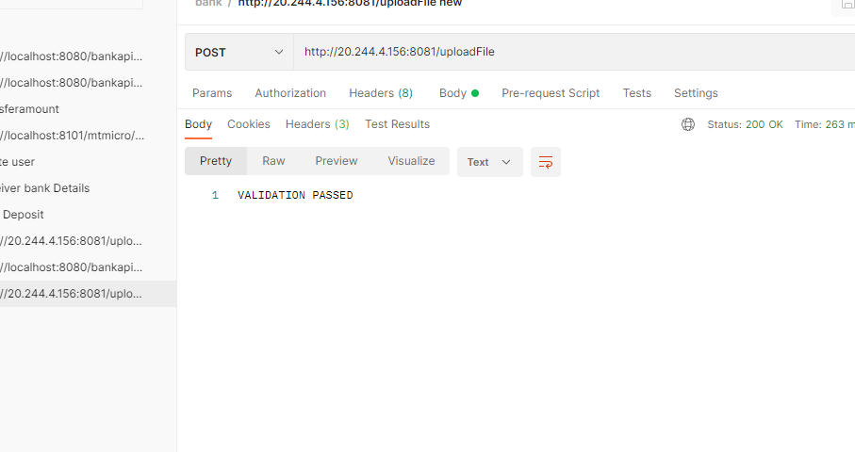

**Validation Passed**

We use String request and response method

So that we Convert MT103 Message to String for transferring

Response

 "status": 200,

    "message": "Amount Transfered Successfully",

    "mtmessage": "{1:F01SOGEFRPPAXXX0070970817}{2:I103INXAXXN1}{3:{103:TGT}}{4:\r\n:20:UNIQUEREFOFTRX16\r\n:23B:CRED\r\n:32A:220907EUR100,75\r\n:33B:EUR1234567,89\r\n:50A:/17203647899155\r\nabcde\r\nBEG\r\nPORTO\r\n:59:/112255461656146\r\nCHARLES \r\n:71A:SHA\r\n-}{5:{CHK:D628FE0165A7}}",

    "mxmessage": "<?xml version=\"1.0\" encoding=\"UTF-8\" ?>\n<Document xmlns=\"urn:iso:std:iso:20022:tech:xsd:pacs.008.001.08\">\r\n    <FIToFICstmrCdtTrf>\r\n        <CdtTrfTxInf>\r\n            <PmtId>\r\n                <InstrId>UNIQUEREFOFTRX16</InstrId>\r\n            </PmtId>\r\n            <PmtTpInf>\r\n                <LclInstrm>\r\n                    <Prtry>CRED</Prtry>\r\n                </LclInstrm>\r\n            </PmtTpInf>\r\n            <IntrBkSttlmAmt>100</IntrBkSttlmAmt>\r\n            <Dbtr>\r\n                <Nm>abcde </Nm>\r\n                <PstlAdr>\r\n                    <AdrLine>BEG PORTO</AdrLine>\r\n                </PstlAdr>\r\n            </Dbtr>\r\n            <DbtrAcct>\r\n                <Id>\r\n                    <Othr>\r\n                        <Id>/17203647899155</Id>\r\n                    </Othr>\r\n                </Id>\r\n            </DbtrAcct>\r\n            <Cdtr>\r\n                <Nm>CHARLES </Nm>\r\n            </Cdtr>\r\n            <CdtrAcct>\r\n                <Id>\r\n                    <Othr>\r\n                        <Id>/112255461656146</Id>\r\n                    </Othr>\r\n                </Id>\r\n            </CdtrAcct>\r\n        </CdtTrfTxInf>\r\n    </FIToFICstmrCdtTrf>\r\n</Document>\n"

}

**CONVERTED MT MESSAGE**

{1:F01SOGEFRPPAXXX0070970817}{2:I103INXAXXN1}{3:{103:TGT}}{4:

:20:UNIQUEREFOFTRX16

:23B:CRED

:32A:220907EUR100,75

:33B:EUR1234567,89

:50A:/17203647899155

abcde

BEG

PORTO

:59:/112255461656146

CHARLES

:71A:SHA

-}{5:{CHK:D628FE0165A7}}

**CONVERTED MX MESSAGE OUTPUT IS :**

<?xml version="1.0" encoding="UTF-8" ?>

<Document >

<FIToFICstmrCdtTrf>

<CdtTrfTxInf>

<PmtId>

<InstrId>UNIQUEREFOFTRX16</InstrId>

</PmtId>

<PmtTpInf>

<LclInstrm>

<Prtry>CRED</Prtry>

</LclInstrm>

</PmtTpInf>

<IntrBkSttlmAmt>100</IntrBkSttlmAmt>

<Dbtr>

<Nm>abcde </Nm>

<PstlAdr>

<AdrLine>BEG PORTO</AdrLine>

</PstlAdr>

</Dbtr>

<DbtrAcct>

<Id>

<Othr>

<Id>/17203647899155</Id>

</Othr>

</Id>

</DbtrAcct>

<Cdtr>

<Nm>CHARLES </Nm>

</Cdtr>

<CdtrAcct>

<Id>

<Othr>

<Id>/112255461656146</Id>

</Othr>

</Id>

</CdtrAcct>

</CdtTrfTxInf>

</FIToFICstmrCdtTrf>

</Document>